# 2024 National Hydrologic Assessment

Released on March 21, 2024

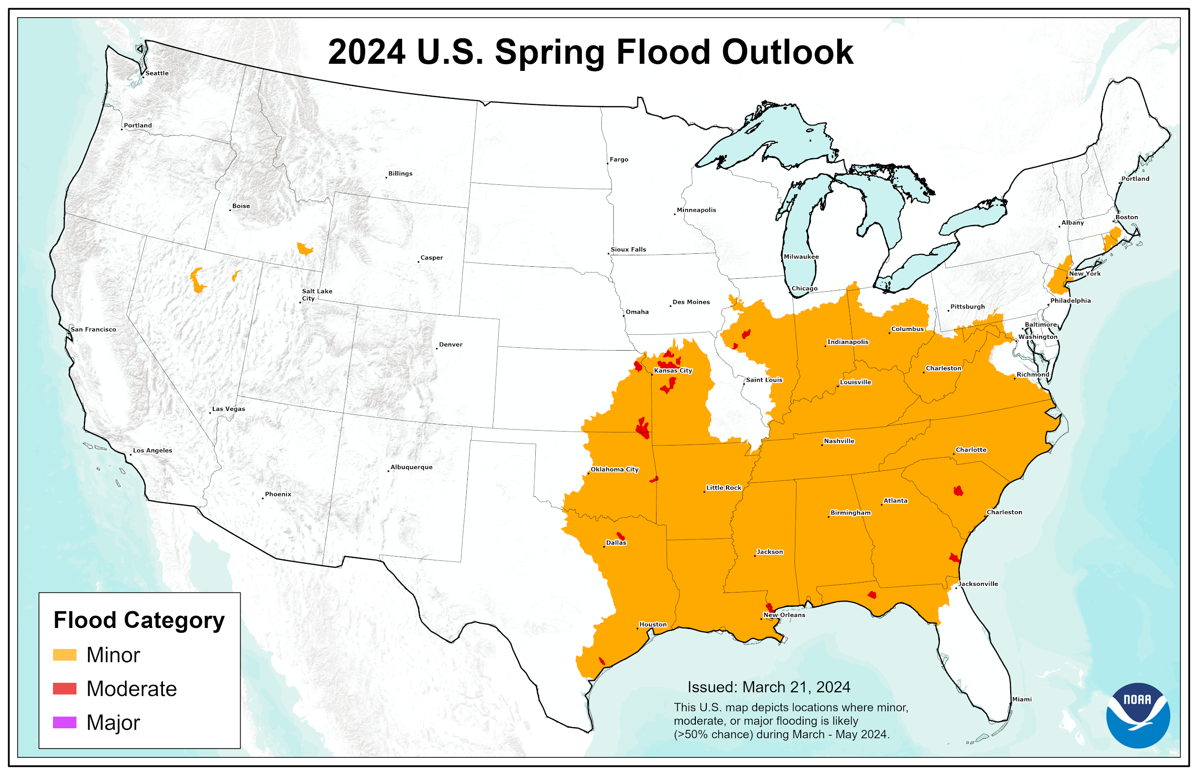

**Figure 1: National Spring Flood Risk defined by risk of exceeding Minor, Moderate, and Major Flood Levels.**

# 

# Executive Summary

The 2024 National Hydrologic Assessment offers an analysis of flood risk, water supply, and ice breakup and ice jam flooding for spring 2024 based on late summer, fall, and winter precipitation, frost depth, soil saturation levels, snowpack, current streamflow, and projected spring weather. NOAA's network of 122 Weather Forecast Offices, 13 River Forecast Centers, National Water Center, and other national centers nationwide assess this risk, summarized here at the national scale.

This spring season, approximately 122 million people are at risk for flooding in their communities, with nearly 350,000 at risk for moderate flooding. No major flooding is expected this spring.

Above normal temperatures, combined with well below average snowpack over the Northern Plains, Midwest, and Ohio Valley, will significantly reduce the flood risk over much of the United States this spring. Moderate flooding is expected over tributaries to the Lower Missouri River in Kansas and Missouri, as well as tributaries to the Lower Arkansas River in Kansas and Oklahoma. Minor to moderate flooding will be possible over much of the southern United States due to typical spring rainfall. Above normal snowpack in northern Nevada and southern Idaho will lead to the potential for minor flooding for higher elevation basins in those areas.

Current water supply forecasts in the western United States indicate normal water supply conditions over California, Nevada, and the Great Basin due to above average snowpack. Over the Northwest, as well as the Colorado, Upper Missouri, Arkansas, and Rio Grande basins, normal to below normal water supply volumes are expected due to a near to below normal snowpack. Longer term water supply issues are possible this summer and fall in the Greater Mississippi River Basin and portions of Texas due to the lack of winter precipitation and expected precipitation patterns through the remainder of spring and into the fall.

In Alaska, spring ice breakup and snowmelt flood potential is forecasted to be normal for the majority of the state, with the exception of portions of the Copper River Basin due to above normal snowpack.

Based on the expected spring flood outlook, average hypoxia zones are expected for the Gulf of Mexico and for Chesapeake Bay.

# Heavy Rainfall and Flooding

The information presented in this report focuses on spring flood potential, using evaluation methods analyzed on the timescale of weeks to months, not days or hours. Heavy rainfall at any time can lead to flooding, even in areas where the overall risk is considered low. Rainfall intensity and location can only be accurately forecast days in the future; therefore, flood risk can change rapidly. Stay current with flood risk in your area with the latest official watches and warnings at [weather.gov](https://www.weather.gov/). For detailed hydrologic conditions and forecasts, go to [water.weather.gov](https://water.weather.gov/ahps/).

**NOAA’s Experimental Long Range River Flood Risk Assessment**

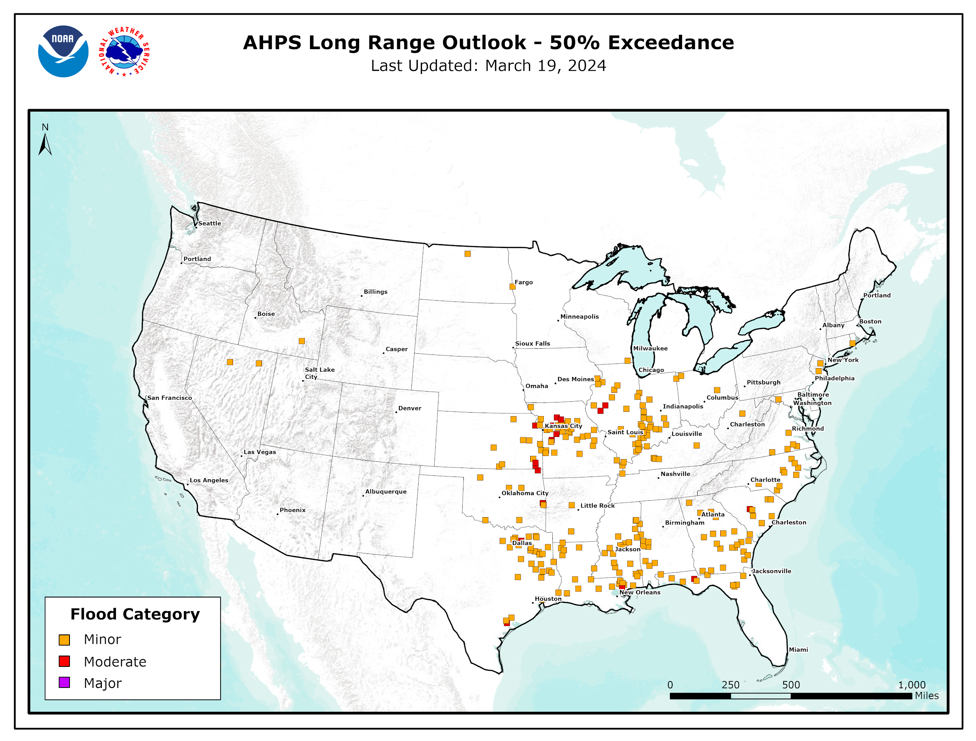

**Figure 2: Greater than 50% chance of exceeding minor, moderate, and major river flood levels during April through June, 2024**

At the request of national partners, including the Federal Emergency Management Agency (FEMA) and the U.S. Army Corps of Engineers (USACE), the National Oceanic and Atmospheric Administration (NOAA) continues its improved decision support services with the “Long Range River Flood Risk” web page available at: [https://water.weather.gov/ahps/long_range.php](http://water.weather.gov/ahps/long_range.php). Here, stakeholders can access a single, nationally consistent map depicting the 3-month risk of minor, moderate, and major river flooding as shown in Figure 2. This risk information is based on NOAA’s Hydrologic Ensemble Forecast Service (HEFS) forecasts which are generated for approximately 2,600 river and stream forecast locations across the nation. With this capability, stakeholders can quickly view flood risk predicted to affect their specific area of concern. The Long-Range River Flood Risk drives the National Hydrologic Assessment by clearly and objectively communicating flood risk at the local level.

The sections below quantify river flood risk based on the river location having a 50% or more likelihood of exceeding minor, moderate, or major flood levels. The National Weather Service (NWS), in coordination with local officials, defines flood levels for each of its river forecast locations, based on the impact over a given area. The flood categories are defined as follows:

* Minor Flooding: Minimal or no property damage, but possibly some public threat (e.g., inundation of roads).
* Moderate Flooding: Some inundation of structures and roads near streams. Some evacuations of people and/or transfer of property to higher elevations.
* Major Flooding: Extensive inundation of structures and roads. Significant evacuations of people and/or transfer of property to higher elevations.
* Record Flooding: Flooding which equals or exceeds the highest stage or discharge observed at a given site during the period of record. The highest stage on record is not necessarily above the other three flood categories – it may be within any of them or even less than the lowest, particularly if the period of record is short (e.g., a few years).

# Current Flooding:

As of the date of this assessment, minor flooding is ongoing in East Texas through the Gulf Coast and into the Southeast, with isolated moderate flooding ongoing and forecast for portions of south Georgia. Flooding in these areas is due to recent heavy rainfall. The outlook presented in this assessment is indicative of flood potential during the upcoming season, and not these ongoing events.

# Potential Major Flood Areas:

Currently, there are no areas expected to experience major flooding. Heavy rainfall at any time can lead to flooding, up to and including major flooding. Rainfall intensity and location can only be accurately forecast several days in the future; therefore, flood risk can change rapidly.

# Potential Moderate Flood Areas:

## Lower Missouri Basin Tributaries

Moderate flooding is possible along several tributaries to the Missouri River in eastern Kansas and central Missouri this spring. Isolated minor flooding is expected on additional tributaries throughout this portion of the basin. Soil moisture values across the basin are below normal with areas of drought in place. Streamflow levels are near to below normal. Flooding in this region is mainly driven by springtime thunderstorm activity and spring flooding is typical in this area.

## Lower Arkansas Basin Tributaries

Moderate flooding is possible in southeast Kansas and eastern Oklahoma along portions of the Neosho and Poteau rivers this spring. Isolated minor flooding is expected on additional tributaries throughout this portion of the basin. Soil moisture values across the basin are near to below normal. Flooding in this region is mainly driven by springtime thunderstorm activity and spring flooding is typical in this area.

**Potential Minor Flood Areas:**

## Southern United States

Minor to isolated moderate flooding is possible from East Texas to the Carolinas this spring. Drought conditions were present throughout much of the region during the fall and winter resulting in reduced soil moisture values. Recent precipitation has increased soil moisture overall, with current values near normal; however, soil moisture in central Louisiana and the Delta region of the Lower Mississippi River Valley remains below normal. Streamflow levels are mostly near normal; however, portions of the Southeast are above normal. Flooding in this region is driven by springtime thunderstorm activity and spring flooding is typical in this area.

## Middle Mississippi Valley

Minor to isolated moderate flooding is possible along portions of the Lower Illinois River and tributaries in Illinois this spring. Soil moisture values are near to below normal due to periods of drought last summer and fall; however, recent snowmelt and rainfall have improved streamflow levels to near normal. Snow is not present in the basin, therefore any flooding in the basin will be solely dependent upon future precipitation through the spring.

## Ohio, Cumberland, and Tennessee River Valleys

Minor flooding is possible across much of the combined Ohio, Cumberland, and Tennessee Valleys this spring. Warm temperatures and below normal precipitation this winter led to minimal snowpack and ice throughout the Ohio Basin. Soil moisture values are near to below normal throughout the region. Streamflow levels are generally near normal south of the Ohio River and in the Tennessee and Cumberland Valleys, and near to below normal north of the Ohio River. Flooding in this region is mainly driven by springtime thunderstorm activity and spring flooding is typical in this area.

## Mid-Atlantic and Northeast

Minor flooding is possible across portions of Virginia, Maryland, New Jersey, and southern portions of New York and New England this spring. Additional areas including the Adirondack Mountains in northern New York, Vermont, New Hampshire, and the mountains of western Maine may also be vulnerable to flooding from steady snowmelt through the spring, particularly if heavy rainfall occurs in the next few weeks. Outside of these areas, little to no snowmelt is available for runoff. Streamflow levels and soil moisture values range from normal to above normal across the region. The potential for flooding due to ice jams is above normal across the northern portion of Maine. Elsewhere, the threat for ice jam flooding has mostly passed.

## Interior West

Minor flooding is possible in the Humboldt River Basin of northern Nevada this spring and in the Portneuf River Basin of southeast Idaho. The presence of above normal snowpack will increase flooding potential on additional tributaries in far northern Nevada and areas south of the Snake River Plain in Idaho. Streamflow levels and soil moisture values range from near to above normal throughout these regions. Various factors such as persistent above normal temperatures that drive rapid snowmelt and rain-on-snow events will be significant factors in any potential flooding.

# Remainder of the Continental U.S.

## Western U.S.

Water supply forecasts are produced by the River Forecast Centers in the western United States. Forecasts are impacted by current hydrologic conditions including snowpack and soil moisture, along with weather forecasts and climate information. As conditions change, especially over the next couple months, water supply forecasts will be updated and available through [the Western Water Supply Forecasts](https://www.cbrfc.noaa.gov/wsup/graph/west/map/esp_map.html) page.

# Water Supply

## Western U.S.

### Northwest

The water supply forecast in the Northwest is roughly divided between north and south, with the Columbia River and tributaries upstream of the Tri-Cities area of Washington expected to experience normal to below normal runoff for April through September. Most of the Snake River Basin, as well as basins in central Oregon, are expected to have normal to above normal runoff for the same time period. Combined, this is expected to produce below normal runoff values for the Columbia River at The Dalles, Oregon. Basins west of the Cascade Mountains are expected to have normal to above normal runoff volumes, with the exception of the Northern Cascades of Washington, where runoff is expected to be normal to below normal. These water supply forecasts are due to mostly below normal snowpack and winter precipitation values in the northern portions of the area, and above normal snowpack and precipitation values in the Snake River Basin and much of Oregon.

### California

Near normal water supply runoff volumes are generally forecast in California for April through July this year. The overall mountain snowpack is generally near seasonal values, with northern areas at 115% of normal, the central Sierra Nevada at 100% of normal, and the southern Sierra Nevada at 95% of normal. Some basins along the Sierra Nevada are expected to experience slightly below normal runoff volumes due to localized areas of below normal snowpack, along with expected above normal temperatures, and below normal precipitation for the month of March.

**Nevada**

Normal to well above normal water supply runoff volumes are forecast for April through July in northern Nevada due to well above normal snowpack. Below normal runoff volumes are expected in western Nevada along the Sierra Nevada due to locally below normal snowpack and winter precipitation values. Statewide, basin snowpack values range from 100% to over 160% of normal.

### Colorado River and Great Basin

Water supply runoff volumes are expected to be below normal over the entire northern and southern portions of the Upper Colorado River basin, with near to above normal over the central parts of the basin. Runoff volumes are expected to be below normal over the Lower Colorado River Basin. Normal to above normal runoff volumes are expected in the Great Basin. Water year precipitation to date has been near to below normal over much of the Upper Colorado Basin, with snowpack conditions ranging from near to below normal in the northern and southernmost areas, and near to above normal conditions through the central portion of the basin. Water year precipitation to date has been near to above normal in the Great Basin, with snowpack generally above normal. Water year precipitation to date throughout the Lower Colorado River Basin has been below normal. Precipitation over the first half of March has helped to increase overall precipitation totals; however, the lack of winter precipitation in many basins will still impact seasonal runoff volumes.

## Water Resources East of the Rockies

### Upper Missouri River Basin

Water supply runoff volumes are generally forecast to be normal to below normal across the Upper Missouri River Basin April through September, with the exception of the Bighorn River Basin in Wyoming, which is expected to have above normal runoff volumes. Snowpack values are normal to below normal through much of the region, with drought present over much of the Northern Rockies of Montana. The Platte River System in Colorado and southern Wyoming have near-normal mountain snowpack.

### Upper Arkansas River Basin

Normal to below normal water supply runoff volumes are forecast across the Arkansas River Basin in Colorado. Below normal water supply runoff volumes are expected in the Canadian River Basin in New Mexico. Snowpack in the Arkansas Basin headwaters is near normal. Snowpack is below normal in the Canadian River Basin with ongoing drought.

### Upper Rio Grande Basin

Near to below normal water supply runoff volumes are forecast for the Upper Rio Grande and Pecos Basin headwaters. Snowpack is near normal in the Upper Rio Grande headwaters of Colorado with near normal to above normal snowpack through much of the Upper Rio Grande Basin and in the headwaters of the Pecos River in New Mexico. Although streamflows are predominantly near normal, drought is present over the basin. This has resulted in below normal soil moisture values going into spring runoff.

### Texas

There is the potential for longer term water supply issues over central and western Texas this summer into the fall. Widespread severe to exceptional drought was present over much of Texas in the late summer and fall of 2023, which provided little to no recharge into rivers and rainfall-driven reservoirs. A wet pattern developed during the winter which significantly reduced drought over the state; however, only reservoirs in eastern Texas saw any significant recharge. Soil moisture values have generally returned to near normal over much of the state, with streamflow levels generally near normal except over south and southwest Texas where streamflows are below normal. Current outlooks from NOAA’s Climate Prediction Center (CPC) suggest normal to below normal precipitation over much of the western portions of the state through early summer, as well as normal to above normal temperatures for the same period. These factors combined suggest a decreased likelihood of significant reservoir recharge while increasing the environmental water demand.

### Northeast

Widespread water supply issues are not predicted over the Northeast this spring. Soil moisture values are generally normal to above normal over the region. Reservoir and groundwater levels are generally near to above normal, with the exceptions of portions of western New York state and Nantucket Island, Massachusetts. Snowpack is below normal with the exception of portions of the higher terrain of New York, Vermont, New Hampshire, and Maine. A small area of drought is present over western New York. Water supply issues may be possible over western New York due to the lack of significant snow cover to provide groundwater recharge unless above normal precipitation occurs.

### Mid-Atlantic

Widespread water supply shortages are not predicted this spring in most locations, assuming near normal precipitation through April 2024. Drought is not present in the region with soil moisture values generally normal to above normal. Groundwater levels are also generally normal to above normal, with the exception of portions of Virginia, Maryland, and West Virginia. Reservoir storage is generally near to above normal across the region (including the Delaware River Basin that supplies New York City water) except in southern areas where near to slightly below normal reservoir levels are being observed.

### Greater Mississippi River Basin Outlook

There is the potential for longer term water supply issues throughout the Greater Mississippi River Basin this summer and into the fall. Temperatures this winter have been above normal over almost the entire basin. The combination of the warmth and areas of below normal precipitation have resulted in well below normal snowpack, especially over the Northern Plains and Upper Midwest. Soil moisture values are below normal for much of the Ohio, Lower Missouri, and Upper Mississippi river basins. The above factors suggest there will be reduced runoff available to sustain normal baseflows on mainstem rivers going through the summer months into fall. This includes the Upper Mississippi, Ohio, Missouri, and Lower Mississippi rivers.

The current outlooks from the CPC suggest above normal probabilities for precipitation over portions of the Ohio, Lower Missouri, and Lower Mississippi river basins in late spring with equal chances of above, normal, or below normal precipitation elsewhere across the remainder of the region. The outlook of above normal precipitation this spring over those basins does not necessarily suggest that baseflows through the region will be sustained at a higher level through the remainder of the year.

### Key Water Supply Locations

|  |  |
| --- | --- |
| **River** | **% of Normal Runoff** |
| **Columbia River below Priest Rapids Dam, WA** | **80%** |
| **Snake River at Lower Granite Dam, ID** | **85%** |
| **Columbia River at The Dalles, OR** | **85%** |
| **Sacramento River Basin, CA (combined)** | **100%** |
| **San Joaquin River Basin, CA (combined)** | **100%** |
| **Bear River at Steward Dam, UT** | **110%** |
| **Weber River at Gateway, UT** | **110%** |
| **Provo/Utah Lake at Jordan, UT** | **100%** |
| **Green River at Flaming Gorge, UT** | **90%** |
| **Colorado River at Lake Powell, AZ** | **90%** |
| **Upper Missouri Basin above Fort Peck, MT** | **75%** |
| **North Platte Basin above Seminoe Reservoir, WY** | **90%** |
| **South Platte Basin at South Platte, CO** | **85%** |
| **Arkansas River above Pueblo Reservoir, CO** | **90%** |
| **Rio Grande at Del Norte, CO** | **85%** |

**Table 1: Seasonal water supply forecast volumes at key locations in percent of normal runoff**

The locations listed above are key forecast locations that can accurately represent the broad water supply forecast for major basins in the Western U.S. Percentages expressed are for the expected volumetric runoff as a percent of average for the climatological runoff period for each river basin. Additional information regarding the outlook for specific river basins and locations may be found at [water.weather.gov](http://water.weather.gov/ahps).

# Alaska Spring Ice Breakup Outlook

There is an average potential for flooding due to snowmelt and spring ice breakup for most of the state with the exception of the Copper River Basin. There are no reports of mid-winter breakups and the corresponding anomalously thick ice. The Copper Basin is worth noting for its above normal snowpack this winter. This outlook is based on observed snowpack, ice thickness reports, and seasonal temperature outlooks.

### River Ice

River ice observations are available for a limited number of observing sites in Alaska. Late February and early March measurements indicate ice thickness is near to below normal across the state. Observations from the Interior range from 65% to 95% of normal, with observations along the mid-Yukon River approximately 85% normal. Observers on the Kuskokwim River reported normal ice thickness. No freeze-up jams or mid-winter breakups were reported across the Yukon and Kuskokwim River basins.

Cumulative freezing degree days (FDD), which can serve as a proxy for river ice thickness, are near normal across most of Alaska due to fairly mild winter air temperatures. Colder conditions were observed across coastal sites along the Gulf of Alaska (Homer to Sitka), where FDD are 110% to 200% of normal. Normal FDD conditions have been observed across South-central and Copper River Valley (105% and 100% of normal, respectively). The West Coast, Interior, and North Slope are near normal ranging from 85% to 100% of normal.

### Snowpack

Analysis of the March 1st snowpack by the Natural Resources Conservation Service (NRCS) indicates a variable snowpack; but generally the statewide snowpack is above normal for the majority of the state.

The snowpack for the Upper Yukon (largely in Canada) is reporting near normal. A handful of sites in the perimeter of the basin are 100% to 125% of normal, but the vast majority are 60% to 90% of normal, bringing the basin total to 92% of normal. The Central Yukon Basin, which includes Eagle, Circle, and Ft Yukon, is above normal at 133%. The Porcupine and Fortymile rivers are reporting well above normal, with 157% and 137% of normal, respectively. The Tanana Basin, which includes Fairbanks and Delta Junction, is near normal at 109% of normal. The Koyukuk Basin has a variable snowpack: along the Dalton Highway it is well below normal, extending to near record maximum near the Yukon River; overall the basin is 125% of normal. The Lower Yukon Basin, which includes the villages of Tanana, Ruby, Galena, and Anvik, have stations reporting between 150% and 200% of normal at the lower elevations and closer to normal at the higher elevations.

The Kuskokwim Basin has a near normal snowpack, although this is only based on four stations. Telaquana Lake in the far southeastern headwaters is below normal due to a mid February warm up. McGrath avoided the warm up and is reporting a near normal snowpack. Lower in the basin, between Aniak and Bethel, observers are reporting a much above normal snowpack.

For the Arctic, the three stations along the Dalton Highway are reporting below normal snowpack.

In South-central Alaska, the Copper Basin has a well above normal snowpack, even greater than in 2022 and 2023 which flooded Glennallen. Every station in the basin is reading above normal, with four record maximums. The Susitna Basin is reporting 122% of normal, with the snowiest locations in the eastern headwaters bordering the Copper Basin. Stations in the Kenai Basin are reporting generally above normal, with the highest returns in the Kenai River specifically. The basin-wide snowpack can be approximated at 121% of normal.

### Climate Outlook

Temperatures during April and May remain the most important factor determining the severity of ice breakups. Dynamic breakups, with a high potential for ice jam flooding, typically require cooler than normal temperatures in early April followed by an abrupt transition to warm, summer-like temperatures in late April to early May.

The CPC outlook through early April favors above normal temperatures across Alaska, except for the Northwest Coast and the western North Slope, where equal chances of above and below normal temperatures are possible. In the Upper Yukon, as well as the Copper and Susitna Basins, the CPC guidance suggests a 60% to 70% chance of above normal temperatures. The three month outlook (April - June) indicates increased chances of above normal temperatures across all of Alaska.

This temperature pattern would reduce ice jam related flood risk along the Kuskokwim and Yukon rivers. These larger rivers are westward flowing and warmer temperatures on the west coast would result in ice degradation prior to the arrival of snowmelt runoff, decreasing the chances for a dynamic breakup.

# Spring Flood Outlook and Implications for Gulf of Mexico and Chesapeake Bay Hypoxia

In the northern Gulf of Mexico, a large area of low-oxygen forms in the bottom waters during the summer months, often reaching in excess of 5,000 square miles. This area of low-oxygen, otherwise known as the “dead zone”, is strongly influenced by precipitation patterns in the Mississippi-Atchafalaya River Basin (MARB), which drains over 41% of the contiguous United States. Changes in precipitation influence river discharges into the Gulf, which carry the majority of nutrients fueling the annual dead zone, so examining spring flood risk in the basin can provide a useful indicator of the possible size of the dead zone during the summer.

The predicted spring flood risk across the MARB will likely lead to average or normal hypoxic conditions in the northern Gulf of Mexico this summer. Large portions of the basin are predicted to have a minor or normal risk of flooding this spring. Absent major flooding, normal springtime discharges of nutrients and freshwater from the Mississippi River are predicted.

In the Chesapeake Bay, recurring summer hypoxia has also been linked to nutrient loading and river discharge, especially from the Susquehanna and Potomac rivers. The spring flood outlook for these basins indicates areas of minor or normal risk of flooding. As a result, an average hypoxia zone for the Chesapeake Bay under typical summer conditions is expected.

Flood conditions, should they occur in the Mississippi-Atchafalaya, Susquehanna, and Potomac rivers, may lead to higher-than-normal springtime discharges and promote formation of a larger hypoxia area. This cause-and-effect relationship can be confounded by weather events, such as tropical storms and hurricanes, which can locally disrupt hypoxia formation and maintenance.

The spring flood outlook provides an important first look at some of the major drivers influencing summer hypoxia in the Gulf of Mexico and Chesapeake Bay. In early August, [NOAA](https://www.noaa.gov/news-release/noaa-and-partners-announce-below-average-dead-zone-measured-in-gulf-of-mexico) will measure and report on the size of the hypoxia zone as part of efforts through the Gulf of Mexico/Mississippi River Watershed Nutrient [Task Force](https://www.epa.gov/ms-htf/) to evaluate efforts aimed at reducing nutrient loading to the Gulf of Mexico. The National Weather Service and Ocean Service continue to work with states to develop [new tools](https://youtu.be/7ZJKpNMCH08) to forecast [runoff risk](http://runoffrisk.info/) which help limit nutrient runoff to waterways by identifying the optimal times for fertilizer application within these and other watersheds.

# About This Product

The National Hydrologic Assessment is a report issued each spring by the NWS that provides an outlook on U.S. spring flood potential, river ice jam flood potential, and water supply. Analysis of flood risk integrates late summer, fall, and winter precipitation, frost depth, soil saturation levels, streamflow, snowpack, temperatures, and rate of snowmelt. A network of 122 Weather Forecast Offices, 13 River Forecast Centers, and the National Water Center (NWC) nationwide to assess the risk summarized here at the national scale. The National Hydrologic Assessment depicts flood risk over large areas, and is not intended to be used for any specific location. Moreover, this assessment displays river and overland flood threat on the scale of weeks or months. Flash flooding or debris flow, which accounts for the majority of flood deaths, is a different phenomenon associated with weather patterns that are only predictable days in advance. To stay current on flood risk in your area, go to [water.weather.gov](http://water.weather.gov/ahps) for the latest local forecasts, warnings, and weather information 24 hours a day.